PROPOSED ACTIVITY FOR
DEEP WATER QUALIFICATION SEA TRIAL OF UNMANNED REMOTELY OPERATED SUBMERSIBLE (ROSUB 6000) IN CENTRAL INDIAN OCEAN
(MARCH – APRIL 2010)
Introduction
Unmanned work class remotely operated vehicle (ROV) had been developed in joint collaboration with EDBOE, Russia and tested for its envisaged functionality up to 1144 m water depth. In addition, successful Gas Hydrates exploration trial was completed during October, 2009 in Krishna Gothavary basin, India at 1037 m water depth. The unmanned submersible shall have direct application for deep water scientific explorations. This will be an effective tool for the scientists, technologists and engineers to have a look at the ocean bottom and perform the required activities.

It is proposed to conduct deep water qualification sea trial in Central Indian Ocean Basin at Polymetallic nodule site. Following are the details of mission activities for the deep water qualification trial of ROV along with its scientific observation payloads.

Mission Objectives
- To qualify the envisaged functionality of the work class ROV
at PMN site in Indian Ocean (~ 5400 m).
• To cruise around the manganese nodule site to obtain high resolution pictures /videos.
• To explore manganese nodule site using ROV mounted sensor, sonar, sampler etc...

System Details

Vessel
Deep water cruise for functionality testing and exploration activity at Central Indian Ocean Basin (CIOB) with work class deep water ROV shall be carried out with Technology Demonstration Vessel Sagar Nidhi owned by NIOT (MoES).

Deep Water Work Class ROV (Depth Rating 6000m)
The ROSUB system (Fig.1, 2.) comprises of ROV, Tether Management System (TMS), Launching and Recovery System (LARS), Control console, Deck power house, Electronics and Instrumentation, Electrical system, Navigational System, Control software, scientific payloads etc.
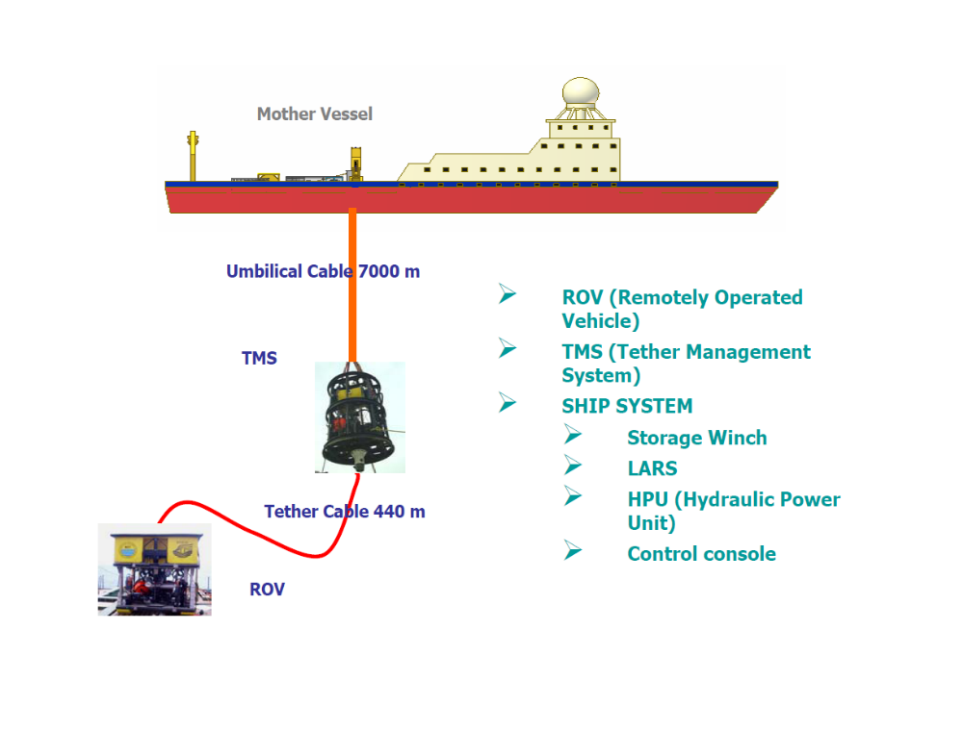
Figure.1. ROSUB 6000 System Components
ROV of ROSUB6000 is an unmanned, free swimming underwater vehicle that has six degrees of freedom and is an electric work class ROV equipped with two manipulators and having an additional pay load capability of 150kg for mounting scientific and mission oriented subsystems. The ROV has seven electrical thrusters for manoeuvring in manual or automatic mode. The ROV has a network of Doppler velocity log (DVL), Inertial navigation system (INS), Acoustic Transponders, multi beam acoustic imaging system and depth sensor for assisting navigation. ROV has several video cameras for monitoring. Moreover, other transducers like oil level, pressure, current, voltage, etc., report the status of the subsystems.

The ROV is fully controlled from a surface station based on the sensor feedbacks. Sensors provide information’s about the depth, position, angular & axial velocities and accelerations, altitude from the seabed, images of the environment and so on. These sensor data are used as the input for the ROV real-time control software, which generates the necessary control signals to perform the intended tasks. In addition, there are often a number of systems like manipulators, homing and docking system, which makes the vehicle more versatile. To accomplish the user specified tasks, dedicated sensors, camera, multi beam sonar, etc., are installed on the ROV.

The thrusters are Brush less Direct Current (BLDC) driven thrusters developing a maximum thrust of 210 kg (forward) and 180 kg (reverse). The frame consists of structural members made up of Aluminium 6061 T6 alloy to reduce the weight. Zinc anodes are mounted to the frame and magnesium anodes are mounted on manipulators for corrosion protection. The submerged weight is compensated by Syntactic foam fitted to the upper part of the frame to have marginal positive buoyancy for ROV. The ROV ballast is fixed in the form of the syntactic foam. The foam, volume being high, will also be used as bumpers for providing cushion against any obstacle impact.

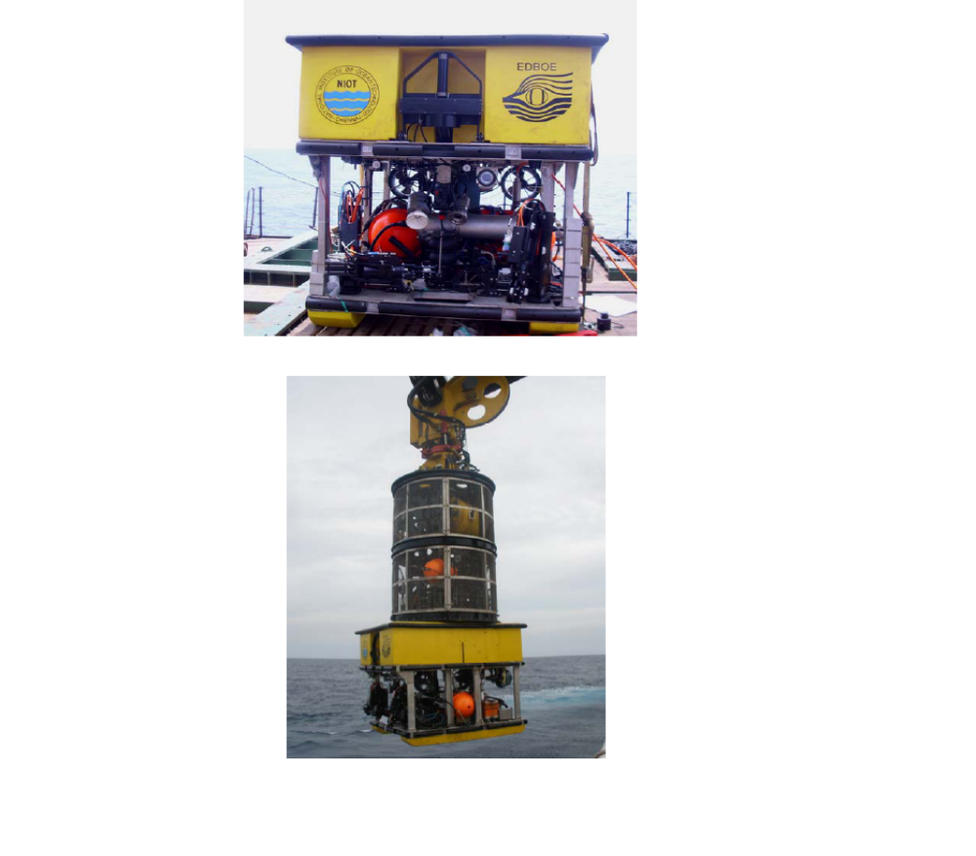
Figure.2 Photographs of ROV and TMS/ROV attached with LARS Head

Specification of ROV:
• Diving depth : 6000 m
• Size : 2.53 X 1.8 X 1.7 m
• Weight : 3600 kg in air; -20 kg in water
• Mechanical structure : Al alloy (AA6061 T6)
• Flotation : Syntactic foams
• Payload : up to 150 kg
• Propulsion : Electrical (7 thrusters of 10 kW)
• Control System :
- National Instrument Real Time Technology (Hardware & Software).
- Single mode Fibre Optic Data and video telemetry.
- Auto control of headings, pitch, roll, depth, altitude.
• Acoustic imaging : Forward Looking Sonar for obstacle
Avoidance
• TV/Cameras : 3 Colour CCD, 2 B&W low light
• Manipulators : 5 function & 7 function (One Each)
• Lights : 7 (LED, HID & Halogen)
• Speed : 2 knots
• Navigation equipments: -
- Doppler Velocity Log (DVL)
- Underwater-Photonic Inertial navigation System (UPHINS)
- Sound Velocity Profiler (SVP)
- Depth sensor
- Transponders
• Electrical power : 6.6 kV AC / 460 Hz;
Sub-sea power converters to give 300 V and 24 V power supply for ROV and TMS operation; 5 kW Hydraulic pumps for manipulator operation
Testing Site details
International sea bed authority had allocated 150,000 sq km area in Central Indian Ocean Basin (CIOB) during 1987 to India. Extensive sea bed investigations were conducted under PMN program by MoES during the past two decades to study nodule distribution, metal abundance in nodule, formation mechanism and sea bed morphology of the allocated Indian Site. Indian Ocean Nodule Field (IONF) occurs in Latitude 10 deg to 16deg 30 minute S and Longitude 72 deg 30 min to 76 deg 30 min E (Fig.3.). Distribution depth of manganese nodule varies from 5000 m to 5400m. Exploration tool developed by NIOT will be tested at the above mentioned site and distance to reach the testing site is 1560 nautical miles or approximately 2600 km. Hence by the normal cruising speed of ship at an average 10 knot/hr, ship can reach the site from the Mangalore port in 7 or 8 days period. It is planned to have sea trial period of 30 days including cruising to the site and preparatory work for system, mobilization and demobilization.
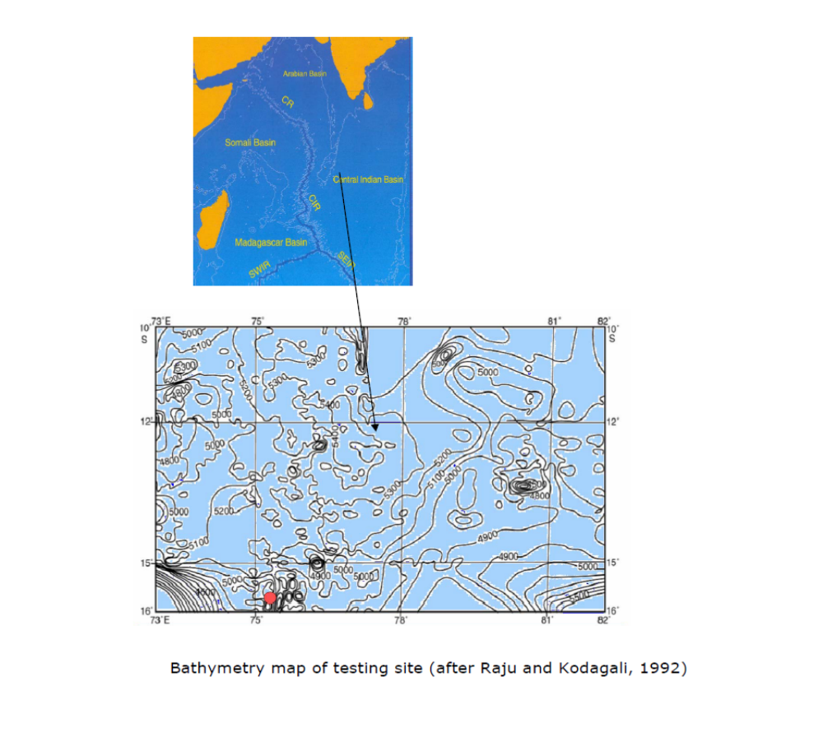
Figure.3. Testing site

System deployment sequence before operation
Following deck systems are interconnected and independently tested before connecting to TMS and ROV
1. Power House system
a. Vacon Drive (Frequency Converter)
b. Transformer (Voltage converter)
c. High voltage protection circuits
d. Insulation monitors
e. EMI filters
f. Power connection to umbilical cable
2. Control Console
a. Processors and monitors for control software functionality
b. Panel mounted with joysticks, hard switches etc
c. Plasma monitors for video display
d. Multiplexer
e. Multibeam sonar processor with software
f. DVR with video overlay system
g. Acoustic positioning system interface
h. Fiber optic communication to umbilical cable
3. 7000 m long Electro Mechanical Kevlar Umbilical cable wounded in storage winch which will be operated in synchronized way with traction winch of LARS.
4. Launching and Recovery System
a. Hydraulic Power Unit
b. Traction Winch
c. Joystick for crane operation to launch ROV with TMS at -4.5 m from ship deck level to release the system below splash zone
d. PLC logic devices and remote control unit for winch Synchronized operation
5. Under water Systems
1. Tether Management System
a. Hydraulic Pump
b. Tether cable with 400 m length cable
c. Latch mechanism
d. Cameras and lights
e. Sub sea power converter
f. Data telemetry system (DTS) and control system
2. Remotely Operated Vehicle
a. Sub sea power converter
b. Thrusters
c. Sensors and Multi beam Sonar
d. 7 function and 5 function Manipulators
e. Syntactic foam for buoyancy
f. DTS, control system and thruster controllers
g. Hydraulic motor

Underwater system TMS and ROV docked together in the ship deck. In addition, umbilical cable with a mechanical termination is connected to TMS after routing direction changing pulley, traction winch and sheaves of LARS. Electrical and Fiber optics connection of the termination are connected with TMS. The mechanical termination fastened to TMS. TMS/ROV together brought and positioned below the LARS latch head. LARS latch dogs hold mechanical termination for lifting and lowering TMS/ROV above the water using crane functionality. TMS and ROV together will be undocked from LARS latching mechanism and the load will be transferred to umbilical cable to lower the ROV and TMS to deep waters of the targeted depth in CIOB (~5400 m).

Mission Duration

Surface preparation | 1 hr
Sub surface system check-up | 0.5 hrs. at 25 m from the surface
Descent | 3 hrs (with 30 m/min of winch speed for umbilical cable release)
Cruise | ROV mounted sonar data collection at < 1 knot at ~ 50 metres above the sea bed covering an area of 0.5 Km² in 2 hrs.
Dive to target depth and observation | 0.5 hr
Inspection, observation, sample collection (sediment and water) using manipulator arms, high resolution video photography | 2hrs.
Contingency | 1 hr
Ascent | 3 hrs (with 30 m/min of winch speed for umbilical cable release)

Total endurance excluding surface preparation is 12 hours. The mission duration during which the scientific pay load and thrusters power are used is ~ 4 hours.

Manoeuvrability & Navigation
• Diving speed : ~ 30 m/min
• Cruising speed : 0 to 1 knots (max 2 knots)
• Positioning : better than 5 m (with LBL)
• Pitch, roll and yaw to the level of high accuracy 0.2 º with UPHINS
• Position keeping : With an accuracy of better than 5 m radius at a
water current of 0.5 knots
• Obstacle avoidance: Manual obstacle avoidance based on visual and
Sonar observation
Visual: Minimum 20 m
Sonar: Minimum 200 m
• Reverse speed : Minimum 1 knots
• Communication : FO (Fibre Optics)

Pre-dive preparation
The preparation for the mission starts with the mission plan and briefing of all the personnel involved. The mother vessel reaches the location and captain gives clearance after consulting weather reports and prediction for the next 72 hours. Pre-dive checks of all mechanical, electrical and electronic equipment are carried out as per the dive test document attached. After clearance from the mission head, the vehicle is launched using the dedicated LARS. Vehicle is taken to 1000 m depth and checking of all the system, especially the water entry sensors, power monitoring sensor status and fibre optic communication systems. After successful checks dive to deeper depths is carried out.

Observation/Survey
Submersible dives up to ~50 meters above the sea bottom. An area of about 0.5 km² is surveyed in 2 hrs using multi beam sonar along the survey lines (Fig.4.) planned earlier. The actual location of the survey will be identified and ROV dives closer to the location of interest with its vertical thrusters operation. After reaching the location high resolution exploration is carried out. High resolution video pictures are being recorded using appropriate lights. Using manipulators sediment/water samples are to be collected using.

System manoeuvring track plan
From TMS position ROV will be undocked. Neutrally buoyant tether cable of 100 - 150 m length is released from TMS to perform manoeuvring operation shown in Fig.4. The manoeuvring of ROV carried out with the help of thrusters and controlled by joysticks from the control console.
ROV Navigation Plan
1F
2 LR
3R
4LR
5F
6LL
7R
8LL
9F
10LR
11R
12LL
13LR
14F
75m
75m
TMS

Figure.4. ROV manoeuvring path using survey lines

Detailed mission plan
Day 1
1. Reaching the site Latitude 13 deg S and 75 deg 30 minutes E
2. Launching ROV & TMS to deep water (~5200 m)
3. Undocking of ROV from TMS ~ 50 m above sea bed
4. By operating the thrusters of ROV and tether winch of TMS, ROV manoeuvred in planned track at a speed of 1 knot
5. In one hour approximately 0.25 km² area may be covered with a swath width minimum of 150 m at a height of 50 m for multi beam sonar. Speed of vehicle 1 knot.
6. During two hours of sonar operation 0.5 km² of sea bed area may be surveyed for fine resolution bathymetry and sea bed characteristics with back scatter.
7. ROV lowered to a level of 5 m above sea bed for video imaging and sampling in detail to the targeted regions.
8. Water sampling and sediment core sampling are carried out at targeted position.
9. Two hours dedicated operation has been planned for sea bed investigation and sampling.
10. All connected sensor (dissolved oxygen, conductivity, sound velocity, depth sensor etc…) data are collected continuously through out the mission.
11. ROV docked back to TMS to proceed for retrieval operation
Day 2
1. Reaching the site Latitude 12 deg 30 minutes S and 75 deg 30 minutes E
2. Launching ROV & TMS to deep water (~5200 m)
3. Undocking of ROV from TMS 75 m above sea bed
4. By operating the thrusters of ROV and tether winch of TMS, ROV manoeuvred in fixed track at a speed of 1 knot
5. In one hour approximately 0.25 km² area may be covered with a swath width minimum of 150 m at a height of 75 m for multi beam sonar. Speed of vehicle 1 knot.
6. During two hours of sonar operation 0.5 km² of sea bed area may be surveyed for fine resolution bathymetry and sea bed characteristics with back scatter
7. ROV lowered 5 m above sea bed for video imaging and sampling in detail to the targeted regions
8. Water sampling and sediment core sampling are carried out at targeted position
9. Two hours dedicated operation has been planned for sea bed investigation and sampling
10. All connected sensor (dissolved oxygen, conductivity, sound velocity, depth sensor etc) data are collected continuously through out the mission
11. ROV docked back to TMS to proceed for retrieval operation
Day 3
1. Reaching the site Latitude 10 deg S and 75 deg 30 minutes E
2. Launching ROV & TMS to deep water (~5200 m)
3. Undocking of ROV from TMS 75 m above sea bed
4. By operating the thrusters of ROV and tether winch of TMS, ROV manoeuvred in fixed track at a speed of 1 knot
5. In one hour approximately 0.25 km² area may be covered with a swath width minimum of 150 m at a height of 75 m for multi beam sonar. Speed of vehicle 1 knot.
6. During two hours of sonar operation 0.5 km² of sea bed area may be surveyed for fine resolution bathymetry and sea bed characteristics with back scatter
7. ROV lowered 5 m above sea bed for video imaging and sampling in detail to the targeted regions
8. Water sampling and sediment core sampling are carried out at targeted position
9. Two hours dedicated operation has been planned for sea bed investigation and sampling
10. All connected sensor (dissolved oxygen, conductivity, sound velocity, depth sensor etc) data are collected continuously through out the mission
11. ROV docked back to TMS to proceed for retrieval operation

Based on the weather window and system integrity mission will continue for further operation

Sensors, Sampling / Measurement
Dissolved oxygen and conductivity sensors are used for scientific observation. Through out the mission Temperature, Conductivity and salinity are measured and continuously logged.

Control & communication
All along the mission, mission head commands the ROV operation with the support of pilot and co-pilot. Similarly scientists are well informed about the tasks being carried out. Pilot alone has the control of the vehicle operation and has the choice to share controls with the co-pilot.
ROV has a continuous Underwater Acoustic transponder contact with surface vessel. ROV position computed using acoustic positioning system, inertial navigation, Doppler Velocity Log, Depth Sensor etc is made available to the pilot and is displayed on the screen visible to all.

Recovery
Thirty minutes before the allotted cruise time pilot alerts the mission head, who in turn checks the completion of tasks of survey, observation, and sample collection. After obtaining clearance the ascent starts. After reaching the surface the ROV with TMS is docked with LARS latching mechanism in splash zone and brought to the deck with crane joystick operation. Data recorded during the cruise is copied on to the storage media for further processing, analysis and archiving. As
per procedure post dive check will be performed and washed completely with fresh water.

Emergency Rescue & recovery
If any abnormality observed in any of the instruments, or if alarm is sounded by any of the sensors, it is immediately notified to the mission head. The decision to abandon the mission is taken in consultation with ship captain.

